

*Issue Q2-2021*

*MHC*

***A Community Group of the Mount Hermon Residents***

***Quarterly Newsletter***

*Welcome! Mount Hermon Community (MHC), is an independent organization for the purpose of friendship, communication, and safety/security serving the nearly 450 homes on the grounds. If you are a resident of Mount Hermon, you are a part of this group.*

*For more information about Mount Hermon Community, email mail@mounthermoncommunity.com. For Mount Hermon Association information, see the last page of this newsletter.*

One of the most important ways to have a vibrant community experience is to have positive communication. There are many opportunities to thank neighbors for helping in small ways to make living in Mount Hermon a good experience (greeting each other with a friendly hello, watching over each other’s properties, making sure leaf blowing is done with neighbors in mind, caring for the air quality, etc.). But, sometimes there are disagreements and irritations which have to be addressed. Please, be considerate and thoughtful in what you say and how you communicate. Seek a win/win outcome. It’s easy to spout off negative feelings, but this could damage your relationships and not lead to a favorable response. Communicate often and in a positive way. Remember to do for others what you would want them to do for you.

*Emergency Exit Points for MHC – Ron Taylor*

In case of an emergency evacuation, be aware of the exits we have out of Mount Hermon. We would like to thank Ron Taylor and Maria Demarest for putting together this list.

**Primary Exits**

• Exiting from central Mount Hermon Community are at Conference Drive, Roaring Camp Road, Grandview Avenue and Summit Avenue >>> onto Graham Hill Road.

• Exiting from Highland Avenue, Woodmill Lane and Redwood Circle >>> onto East Zayante Road

• Exiting from Woodwardia Ave, Lilac Lane, Acacia Ave., and Canyon Road >>> onto Mount Hermon Road (there are no left turns when entering/exiting from this area)

**Alternate Exit**

In certain emergency situations where Conference Drive is blocked, an exit through Ponderosa Lodge (a MHA facility) will be created via ascending Ridgeway into and through Ponderosa Lodge in order to exit >>> onto Graham Hill Road near the County Youth Facility. This is a gated route requiring an MHA representative to open the gates for this route. *[A secondary exit through Redwood Camp (also a MHA facility) via Parkway Avenue, is not a viable route due to weight restrictions for the two bridges crossing Zayante Creek]*

*Better Communication – Reggie Coates*

*Newsletter Contents:*

*• Welcome!*

*• Better Communication*

*• Emergency Exits*

*• Mapping MHC Homes*

*• News & Reminders*

*• Useful Contacts*

*Mount Hermon Community*

*Mapping Our Neighborhood through C.E.R.T – Laurie Shipley*

***Safety Corner >>>***

We are working on identifying who lives at each address in Mount Hermon and if they have special needs. Older residents may need a buddy to help in emergencies. Laurie Shipley is a certified C.E.R.T representative and will be helping us accomplish this by the end of summer. We need everyone’s help! This will greatly help emergency organizations such as our local police and fire departments. Each resident will receive a brochure that will explain more and include emergency signs in case of an emergency.

Below is a map of Mount Hermon with 10 areas covered by 10 Area Representatives (Area Reps). The Area Reps will be contacting each resident in their area to identify their name, address, contact information (email, phone, or both), and any special needs. If you would like to help speed up the process, you could send your name, address, and contact information (email, phone, or both), and any special needs to [mail@mounthermoncommunity.com](mailto:mail@mounthermoncommunity.com) and we will make sure the appropriate Area Rep will get it.

Here are the MHC Area Reps: 1. Reggie & Sherri Coates; 2. Ron Taylor; 3. Cheri Andrews; 4. Aubrie & Adam Hensleigh; 5. Kimberly Miller; 6. Diana Bond; 7. Maria Demarest; 8. Kerry Phibbs; 9. Laurie Shipley; 10. Tim Galleher

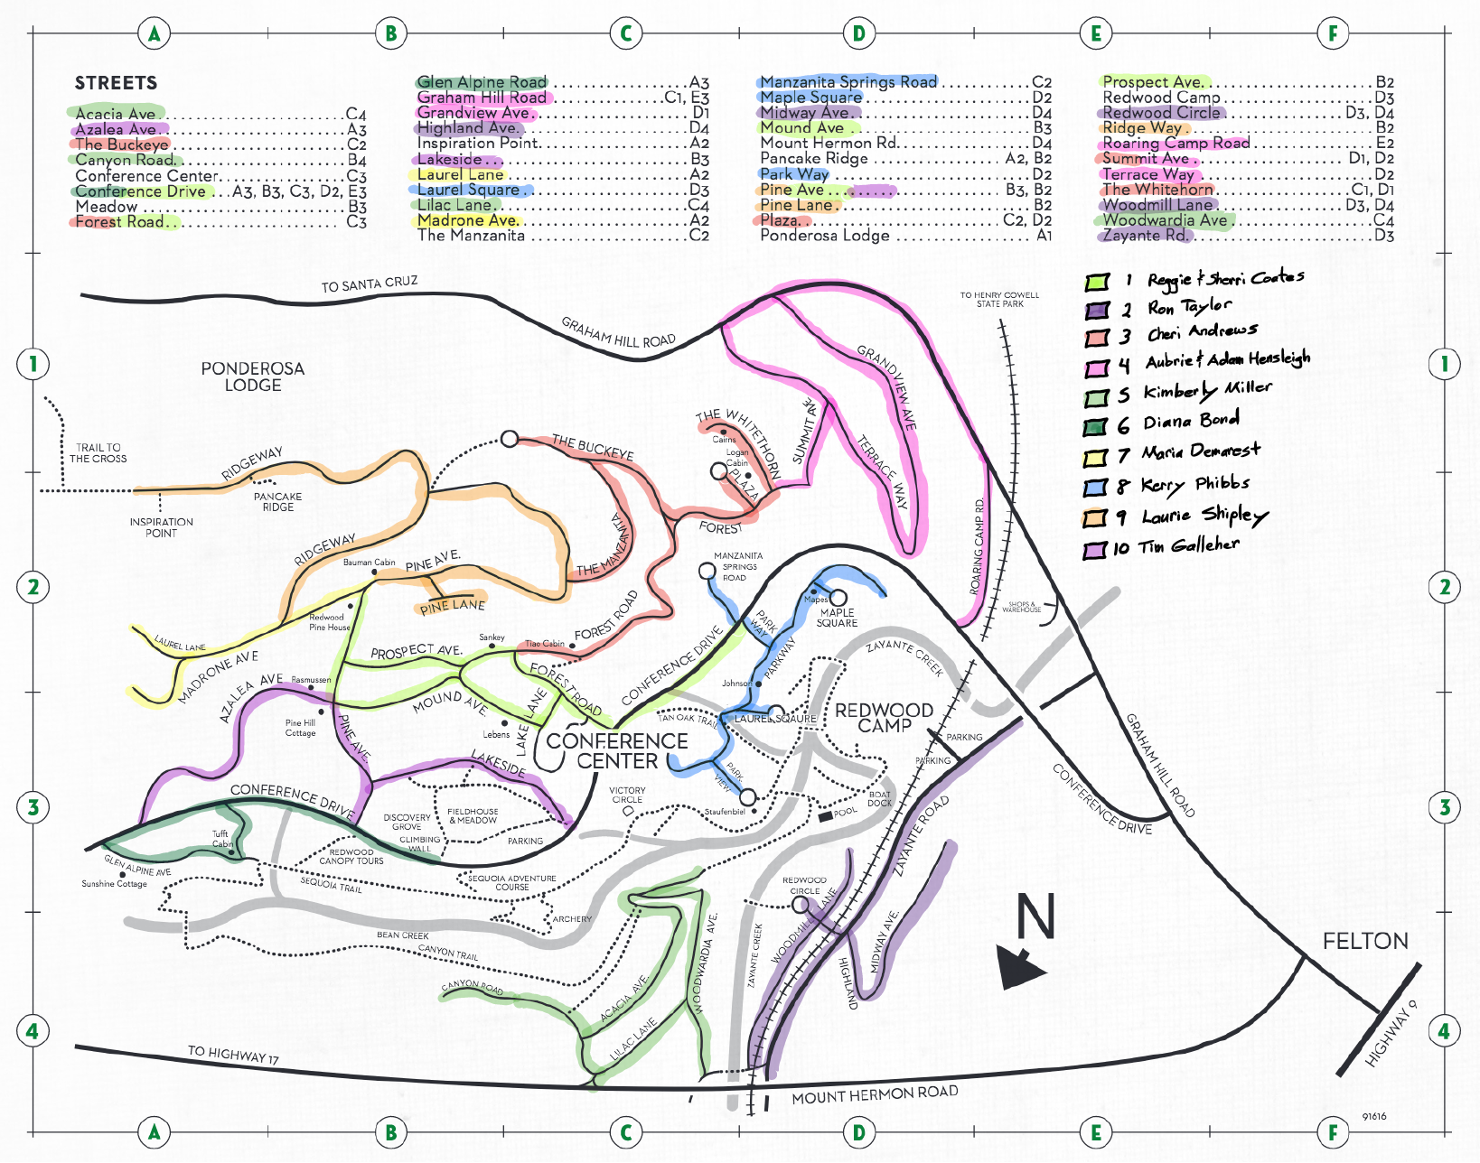

*News & Reminders*

* **Dates for 2021** - The pandemic has kept us from getting together this last year, but we want to keep in touch, keep in the know, and enjoy more activities as we get through the COVID-19 virus. There are four events we are planning this year (2021), so mark your calendar. Unfortunately, we will not be having the Fun Day in the summer because there are too many uncertainties with the pandemic right now.

**~ Thursday, April 29 - Spring MHC General Meeting** (by Zoom). Sgt. Jason Dunn will share about safety and crime; Fire Chief Gray will share about fire safety; Lynn Sestak, with FireSafe Santa Cruz, will be speaking on MHC becoming a Firewise Community; Bill Fernald will be sharing about Mount Hermon Community registration for the summer; and Bryan Hayes will share about Mount Hermon Association details including a report on the Roads, Trails, Bridges expenses for 2020. We will send another email the week before with the Zoom information.  
  
**~ Sunday, May 9 - Chipping program for the community**. After the storms a couple of months ago, MHA worked hard to clear the Roads, Trails, and Bridges and was able to catch some of the other debris, but not all. MHA is offering a chipping program with the final gathering day Sunday, May 9th. Chipping piles have to be on the road by May 9th! The tree service will only accept branches and shrubs 1” diameter to 4” diameter. No leaves, twigs or things that can go in a green bin (they can’t chip leaves), lay the branches in one direction…no criss crossing, preferably with all cut ends together. Chipping will be street by street over two weeks after May 9th and they will not return to a spot twice. Along with the chipping program, MHA will provide their yearly roadside vegetation maintenance. It will start the same day and will be in tandem with the chipping program. As a guideline they cut back 3 feet from the asphalt and 12 feet high. MHA will send out more details as it gets closer.  
  
**~ Thursday, October 28 - Fall MHC General Meeting** (in person). We will give more details later as to where it will be.  
  
**~ Tuesday, December 7 - MHC Neighborhood Christmas Dinner**. We expect things to be better in December, so we’re planning on continuing this wonderful tradition for those who live in Mount Hermon. Ticket sales will open up November 1st online and at the MHA Registration Office.

* **Firewise Community** We are in the process of becoming a Firewise Community. The MHC point person for this is Adam Hensleigh (https://nextdoor.com/profile/56122510/). Lynn Sestak, with FireSafe Santa Cruz, will be speaking at our Spring Meeting to coach us in how to become a Firewise Community. To find out more about fire safety preparedness, visit our website at: <http://mounthermoncommunity.com/2020/10/07/fire-safety-preparedness/?preview_id=935&preview_nonce=7d1dc14f1e&preview=true>

To learn more about Firewise Communities please visit the following page:

<https://www.nfpa.org/Public-Education/Fire-causes-and-risks/Wildfire/Firewise-USA/Become-a-Firewise-USA-site>

* **Nextdoor.com** Please, consider joining Nextdoor.com. This social media platform not only provides updates from Mount Hermon Association but from all of our local agencies as well. It’s a resourceful tool to have in order to connect and communicate with your neighbors and surrounding communities. MHC and MHA use this platform frequently for updates to our community including but not limited to events, road closures or maintenance, water maintenance and updates and accessibility of Mount Hermon amenitites. You can put perimeters to include only Mount Hermon information.
* **MHC Email List** Make sure you are on our MHC Email List to receive the latest updates pertinent to Mount Hermon residents. We use this list to send out the quarterly newsletter, communicate emergencies, and inform residents of what is going on with MHC and MHA as it applies to MHC. We want to make sure everyone in Mount Hermon receives these emails, so ask around and see if your neighbors are on this list. If not, have them contact [mail@mounthermoncommunity.com](mailto:mail@mounthermoncommunity.com) and ask to be on the email list. This is a private list used only for MHC.
* **Speeding** Use caution and reduce your speed while driving within Mount Hermon. Recently, many residents have been traveling less and often walking on our beautiful community streets. Please, obey the rules of the road and significantly reduce your speed.

*Useful Contacts*



President: Reggie Coates

Vice President: Ron Taylor

Secretary: Maria Demarest

Treasurer: Cheri Andrews

Contact: mail@mounthermoncommunity.com

Road, Trails, & Bridges Questions:

Chris Dumonceaux

(831) 335-4466 chris.dumonceaux@mounthermon.org

Water Questions:

Dale Pollock

(831) 335-4466 dale.pollock@mounthermon.org

Property/Parcel Questions:

Bryan Hayes

(831) 335-4466 bryan.hayes@mounthermon.org

Homeowner Billing Questions:

Accounting Office

(831) 335-4466 water.dept@mounthermon.org

*MHA Contacts:*

*MHC Contacts:*